**31 Oct 2014** **The Weekly Bulletin of Rotary Club of Kathmandu Mid-Town** **bc-17/10.014**

|  |
| --- |
|  |

District: 3292 Web:www.rotarymidtown.org.np Club Id: 26776

**OCTOBER IS VOCATIONAL SERVICE MONTH**

**Celebrating**

**25 Years in Rotary**

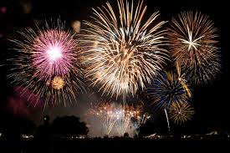



Club’s Regular Weekly Meeting : Friday, 24 October :

Regular weekly meeting # 1251 of the Club was held on Friday morning at Hotel Annapurna.

Extracts of the Meeting Minutes # 1251 are given below:

“7. A few remarks by Pres Kul Chandra

“8. The guest speaker for the day, Mr Bhim Udas was introduced by Pres Kul Chandra. He shared his most recent thoughts on 'Development Issues in Nepal' since he has been a development professional for many decades. Mr Udas began the talk by giving a brief overview of development in Nepal over the past five decades. He went on to say that Nepal needs a new plan for a dynamic and sustainable economic growth to develop its infrastructure, to improve quality of life, and to better utilise its natural and human resources. He also outlined some of the problems as he saw them and highlighted political instability and a lack of vision for development. The question and answer session that followed the talk was lively and entertaining since many of our members are involved with different aspects of development. The vote of thanks was offered by Rtn Bhairaja.

“9. Information from RI District 3292:

- Rotary District 3292 announces a ‘South Asia Conference on Peace: 6-9 February 2015 in Lumbini, and would appreciate good participation from your Clubs. Confirmation of Rotary International President (RIP) Gary Huang’s availability to participate.

- The Gopal and Kamala Rajbhandari Rotary Award for Vocational Excellence 2014/15 will be awarded on 7th Feb 2015. The award money is Rs.10 lakh. This year the committee has decided to grant award in the field of Art and Culture. This year the committee has decided to seek award nomination from the general public as well; but, such nominations should come through a Rotary Club. Nomination forms are attached to these Minutes. Please send nomination to the Rotary District Secretariat in Thapathali, care of Rtn. Diwakar Rajkarnikar (Chair, District Vocational Award Extended Committee) before 15th December 2014.

- ROTA QUIZ You are kindly requested to volunteer for the Rota Quiz Team. We will need a team of 4 with and a team leaders as well as stand by candidates. Names of volunteers needed before the end of October 2014.

- The membership list for RC KTM Mid-Town is being circulated. Please make any needed additions/corrections and return to Mr Dahal.

- Members present: 12 ”

# Weekly Meetings and Programs :

|  |  |  |
| --- | --- | --- |
| Date | Program/Speaker | Topic of Presentation |
| 31 October | Thomas P Wagner, Green Building Associates | Passive Solar Greenhouses in High Altitude Villages of Nepal |
| 7 November |  |  |
|  |  |  |
|  |  |  |

Friday, 31 October :

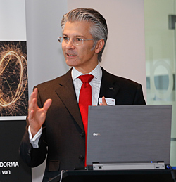

**Thomas P. Wagner** will be our Guest Speaker on Friday, 31 Oct meeting. He is a semi-retired

Stanford PhD (Civil Engineering), licensed Civil Engineer and General Contractor, currently working

part-time as a green building consultant doing green building certifications in the Silicon Valley in

California. He designed and built one of the first passive solar houses with 2 attached greenhouses and

thermal mass in 1982 in the heart of Silicon Valley, California, USA .

He managed design and development of North American commercial and industrial Photovoltaic projects for BPSolar including a large single axis tracker system for a US Marine base. Hedid the first feasibility study of a wind turbine farm for Pacific Gas and Electric company in 1979 which led to the world’s first wind turbine farm in Altamont Pass CA. He was involved in cleaning up many contaminated superfund sites in Silicon Valley. He worked on the design of the Dezful Irrigation Project in Iran. He was consultant for Ford foundation in India in 1972 in water resource planning in Rajasthan.

Dr Wagner will be talking on his project : Passive Solar Greenhouses in High Altitude Villages of Nepal.

**Nepal Vision for Solar Greenhouses**

“I have a vision to bring low cost, appropriate regional technology, locally built and operated solar greenhouses to high altitude remote villages in the Nepal Himalayas. These greenhouses will allow local residents to grow fresh vegetables year round to expand their diet and thus their health and quality of life and provide business opportunities for supplementing incomes by selling vegetables locally.” - Tom Wagner

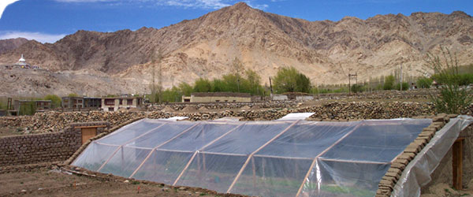

**How Ebola kills You : It’s Not the Virus**

Ebola has a nasty reputation for the way it damages the body. At the end stage of the disease, you have small leaks in blood vessels. You end up with essentially no blood pressure. Your body temperature drops and you go into shock.

But when you look at the nitty-gritty details of an Ebola infection, a surprising fact surfaces: The virus isn't what ends up killing you. It's your own immune system. The normal job of the immune system is to eliminate infections. But when it's activated at extreme levels or it's out of control, it becomes damaging to the host. The most extreme immune attack is the "cytokine storm." Although many viruses, like bird flu and SARS, can trigger this shock and awe assault, Ebola is probably the best at it. And at the end of an Ebola infection, it's the cytokine storm that kills you.

In essence, a cytokine storm is an SOS signal that causes the immune system to launch its entire arsenal of weapons all atonce. This last-ditch, kamikaze attack hurts the virus. But it leaves behind tons of collateral damage. Blood vessels take the brunt of it.

The cytokine storm makes the blood vessel walls more permeable. So the arteries, veins and capillaries start to leak blood and plasma. The storm also triggers a big release of nitric oxide, which thins out the blood and damages vessels further. All these factors combine together to reduce blood pressure to dangerous levels. So you don't die of blood loss, but from something similar to severe septic shock.

So how does Ebola trick the immune system into launching the cytokine storm? To answer that, we have to back up to the moment when the virus enters the blood. Ebola immediately zeroes in on and infects cells of the immune system. One target is dendritic cells. During less dangerous infections, say from a cold, dendritic cells gobble up the virus and then instruct other immune cells to make antibodies tailored specifically to *this* particular virus. The antibodies then stick onto the virus' surface and stop it from infecting more cells. This is how we clear out viruses from our blood. But Ebola is way more sophisticated than a cold. Ebola tiptoes quietly into dendritic cells and essentially shuts off their alarm system. So the immune system doesn't know it should make antibodies to Ebola. The body is left wide open, with no protection. Then Ebola starts copying itself like crazy. The virus grows uncontrollably and infects many organs. Eventually, cells start dying and exploding. That's when the immune system goes haywire. Dying cells release all their contents into the blood. The immune system is doing way more damage than good at this point. In other words, our bodies' response to Ebola is often too much, too late — and frequently fatal.

*Source:* *Michaeleen Doucleff / Internet News*

**Chhath Parva** **: 27 - 30 October**

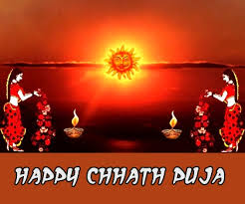

**Chhath parva, also known as Dala Chhath,** is celebrated by natives of Mithila

region of Nepal and India. The word ‘Chhath’ has its origin in ‘sixth’ as it is

celebrated on the 6th day or ‘Shasthi’ of the lunar fortnight of Kartik. Chhath is

mainly characterized by riverside rituals in which the Sun God or Surya is

worshiped, giving it the name of ‘Suryasasthi.’ The morning ‘arghya’ is a prayer

for a good harvest, peace and prosperity and the evening ‘arghya’ is an expression

of thanks to the benevolence of the Sun God for all that he has bestowed during

the year gone by.

The first day of Chhath is called ‘Nahai Khai,’ which literally means ‘bath and eat’.

On the second day called ‘Kharna,’ the devotees observe 8-12 hours of anhydrous

fast and end their ‘vrat’ in the evening after performing puja with the ‘prasad’ offered to Surya. This normally consists of ‘kheer’, ‘puris,’ and bananas, which are distributed to one and all at the end of the day. The third day is spent in worship and preparing ‘prasad’ while fasting sans water. In the evening whole family accompanies the devotee to a riverbank, or lake for evening ritual called the ‘Sandhya Arghya’ or ‘evening offering’ to the setting sun. Kosi is held after the sun set. The lights are lit. The lamps are kept under a canopy of five sugarcane ticks.

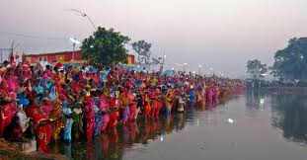

The fourth day of Chhath is considered the most auspicious

when the final morning ritual or ‘Bihaniya Arghya’ is performed.

The devotees along with their family and friends congregate on

the bank of the river to offer ‘arghyas’ to the rising sun. Once

the morning ritual is over, devotees break their fast by taking a

bite of ginger with sugar. This marks the end of the rituals as

joyous celebrations ensue.

*Source: Internet News*

**Committee Chairs’ Column:** *(This column is for use by chairpersons of 5 permanent committees: Club Administration, Membership, Public Relations, Service Projects, and the Rotary Foundation)*

On Lighter Side :

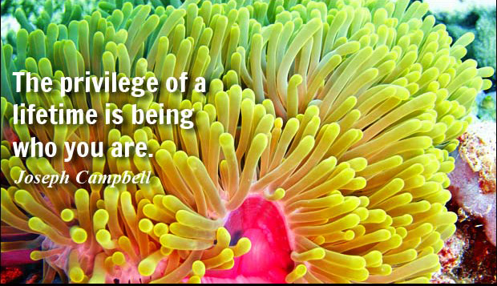

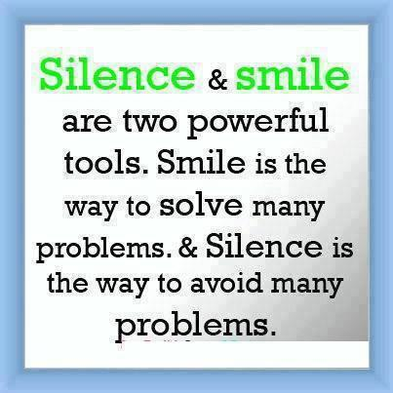

**A THOUGHT FOR TODAY:**

**[Learn from yesterday, live for today, hope for tomorrow.](http://thinkexist.com/quotation/learn_from_yesterday-live_for_today-hope_for/222120.html)**

**[The important thing is not to stop questioning.](http://thinkexist.com/quotation/learn_from_yesterday-live_for_today-hope_for/222120.html)**

*[- Albert Einstein](http://www.brainyquote.com/quotes/quotes/g/georgebern102967.html" \o "view quote)*

**Members’ Corner:** *(This column is for Club members to express anything they would like in matter of Club activities, Club administration, Club issues or on Breakfast Chatter, or on anything else that would be of interest to fellow members.)*

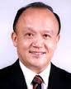

I want to, along with my district governors, reach out and try to link different clubs from

different countries together so we can find the right communities in need. That's one of the great things about being an international organization: the ability to bring different cultures

and backgrounds together to find a common cause.

**RI President GARY C.K. HUANG**

Please send information on club activities, progress reviews on service projects, relevant photos etc to:

BC Editor: RR Shrestha email: rryesrr@gmail.com

## 31 October 2014 The Weekly Bulletin of Rotary Club of Kathmandu Mid-Town bc-17/10.014